Name:

2.2 Cell Metabolism | Objectives
2.2.6 Movement through cell membranes | - Define the term: Selectively permeable  - Explain the role of selectively permeable membranes.  - Define the terms: osmosis & diffusion  - Give examples of diffusion and osmosis.  - Define the term: turgor.  - Explain turgidity in plant cells.  - Describe the application of high salt or sugar concentration in food preservation.

Diffusion is the movement of molecules from a region of high concentration to a region of low concentration (until the two concs. are the same).

It is passive i.e. no energy required.
Rate of diffusion depends on factors such as temp., conc. difference, distance, surface area, type of medium and mass of substance.
Faster diffusion if temp. high, short distance, big conc. difference, gas medium.

e.g.:
- gaseous exchange in alveoli of lungs
- diffusion of oxygen into a cell for respiration and carbon dioxide out of mitochondrion.
- gaseous exchange in leaf e.g. carbon dioxide for photosynthesis.
- the way the smell of perfume, bread baking and stink bombs spread
- sugar in tea.
- transpiration of water vapour through stomata of leaf.
- absorption of food in villi.

Osmosis is the movement of water molecules from a region of higher water concentration to a region of lower water concentration across a semi-permeable membrane.

e.g.
- water absorption by roots
- water movement from cell to cell
- water reabsorption by nephron (in kidney)

Hypertonic solution = higher solute concentration than normal.
Hypotonic solution = lower solute concentration than normal.
Concentrated solution = larger amount of solute in solvent
Selectively permeable membranes allow some but not all substances through e.g. biological membranes, cellophane, visking tubing, dialysis tubing. They allow substances such as water, oxygen and carbon dioxide to pass freely but do not allow sugars, proteins and salts to pass through easily.

Mandatory expt. To demonstrate osmosis.
Expt. A.
To demonstrate osmosis in an artificial cell using visking tubing with syrup/sugar solution/salt solution surrounded by water.

Result: Bag swells up due to osmosis.

Expt. B: To demonstrate osmosis in a living cell - potato and salt.
Boil potato for 3 mins. Leave potatoes> 60 mins. for result.

Result:
- Raw potato and salt - water in hollow due to osmosis.
- Boiled potato and salt - remains the same. Cell membranes destroyed by heating and therefore osmosis cannot occur.

Expt. : To demonstrate osmosis using starch in Viking tubing surrounded by iodine solution.

Results:
- Bag swells up – osmosis
- bag contents go blue-black - iodine reacts with starch
- reddish-brown iodine in beaker loses its colour - iodine diffuses into bag.

Plant cells and osmosis
Expt.: To investigate plasmolysis in plant cell i.e. rhubarb/onion.

Result:
- In the plasmolysed cell (due to salt (10% solution)/sugar) the vacuole, cell membrane and cytoplasm shrink.
- In hypotonic solution, e.g. water, deplasmolysis occurs.

Plasmolysis is the shrinking away of cytoplasm from the cell wall due to loss of water by osmosis.

e.g.
- lettuce becomes limp due to soaking in salty salad dressing
- when cut flowers lose water due to evaporation.

Turgor or turgor pressure, is the pressure of the cytoplasm and vacuole against the cell wall of a plant.

A plant cell is turgid (firm) when no more water can enter the cell by osmosis i.e. outward pressure of vacuole (turgor pressure) = resistance of cell wall. When a cell is fully turgid it can support its own weight. When cells lose turgor a plant wilts as cells become flaccid (limp) and cannot support their own weight.
(Car tyre, football)

Animal cells and osmosis
To demonstrate osmosis in red blood corpuscles.

Result:
- If an animal cell (RBC) is placed in a hypertonic solution (0.9%) water moves out and cell shrinks (crenation).
- If put in a hypotonic solution water moves in and the cell expands and bursts - haemolysis.

Amoeba live in freshwater and have a contractile vacuole to get rid of the water.
Multicellular animals use kidneys to carry out osmoregulation of our blood.

Application of osmosis to food preservation
Fish and meat e.g. bacon can be preserved by placing in salt solution. This causes the tissues and any bacteria, if present, to become dehydrated. Sugars also used as a preservative of fruits, especially in jams.

Active transport is the movement of molecules across a cell membrane against a concentration gradient i.e. low to high. Energy is required.
Transport proteins actively pump molecules such as starch across a cell membrane.
e.g.
- absorption of minerals from soil by root hairs
- reabsorption of glucose/vitamins in nephron of kidney
- thyroid gland removes iodine from blood

Leaving Cert Questions
Section A
2013 HL
5. (a) (i) In relation to structures such as the cell membrane, explain the term selective permeability.
____________________________________________________________________________
(ii) Suggest an advantage to the cell of having a selectively permeable membrane.
____________________________________________________________________________
(iii) Name two substances that enter a human muscle cell by diffusion.

2015 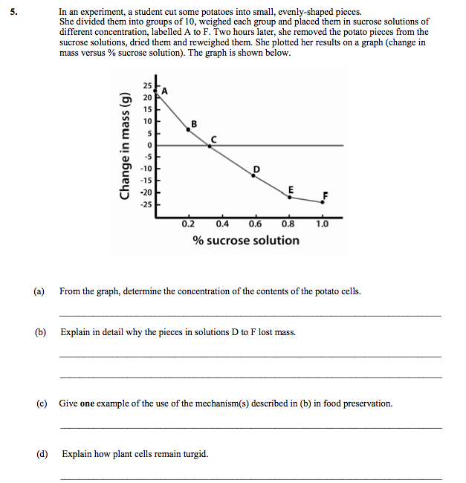Give a feature of a plant cell that allows it to remain turgid for long periods.
____________________________________________________________________________
(iii) Suggest a way in which turgor is of value to plants.
____________________________________________________________________________

Section B
2012 HL
7.
(vi) What did you use as the selectively permeable membrane in your investigation of
osmosis?
________________________________________________________________________________

2013 HL
9.
(b) Answer the following in relation to investigations that you carried out in the course of your
practical studies.
(ii) When demonstrating osmosis:
1. For what purpose did you use Visking tubing, potato tissue or some similar material?
__________________________________________________________________________
2. At the end of the demonstration, how did you conclude that osmosis had occurred?
__________________________________________________________________________

2017
9(b)

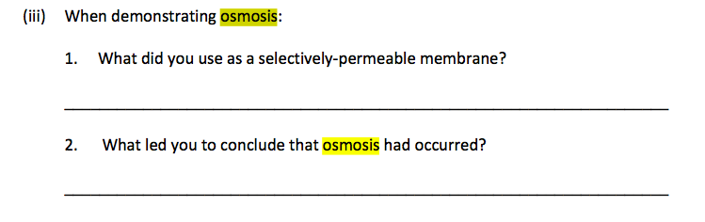
Section C
2008 HL
14. (c)
(ii) Water enters the outermost cells of the root by osmosis. What does this tell you about the cell
sap of these outermost cells?
(iii) Osmosis has been described as a special case of diffusion. Explain why.
(iv) Describe an investigation that you carried out to demonstrate osmosis.
(v) Describe how minerals such as nitrates enter the root of a plant from the soil.

2010 HL
14.
(c) (i) In relation to membranes in cells, explain what is meant by selective permeability.
(ii) Give two locations in a cell at which there is a selectively permeable membrane.
(iii) 1. What is diffusion?
2. In the case of a named molecule, give a precise location at which it diffuses in the human
body.
(iv) Explain the biological basis for the use of high sugar or high salt concentrations in the
preservation of food.

2011 HL
14. (c)
(iv) The cell membrane is described as being selectively permeable. What does this mean?
(v) Why is diffusion alternatively known as passive transport?
(vi) Osmosis may be described as “a special case of diffusion”. Explain why.
(vii) Describe, with the aid of a labelled diagram, how you demonstrated osmosis in the laboratory.
(viii) Name the structure by which Amoeba gets rid of excess water that has entered by osmosis.

2012 HL
15.
(c)
(ii) Homeostasis often requires an organism to exchange materials between different
tissues, or between itself and the external environment by diffusion, osmosis, and
active transport. Explain each of the underlined terms.
2016
14©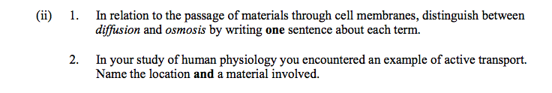

Ordinary Level

2013 OL
8. (a) (i) Which substance moves through cell membranes by osmosis?
..............................................................................................................................................................
(ii) Name one other term used in biology to describe the movement of substances through cell
membranes.
...............................................................................................................................................................
(b) Answer the following in relation to an activity you carried out to demonstrate osmosis.
(i) In the space below, draw a labelled diagram of the apparatus you used in your demonstration.

(ii) Suggest a control that you might use in this activity.
...............................................................................................................................................................
...............................................................................................................................................................
(iii) State the result(s) of your investigation.
...............................................................................................................................................................
...............................................................................................................................................................
...............................................................................................................................................................
...............................................................................................................................................................
(iv) Briefly explain the result(s) referred to in part (iii).
…………………………………………………………………………………………………...……
………………………………………………………………………………………………...………
2008 OL
15 (a) (i) Water enters the roots of plants by osmosis. Explain what is meant by osmosis.
(ii) Describe how you demonstrated osmosis as part of your practical activities.

Answers

Section A

2013 HL Q5
5. | 1 + 1 + 8 + 6 + 4(1)
 | (a) | (i) | Only certain substances (or named) allowed through
 |  | (ii) | Substances can be kept in (or out) or substances can be let in (or out)
 |  | (iii) | Oxygen / glucose / water / amino acids / phosphate (or P) / iron Any two
 | (b) | (i) | Pressure / of cell contents (or described) / on cell wall Any two
 |  | (ii) | Vacuole or cell wall or cell sap
 |  | (iii) | Support (or described)
2013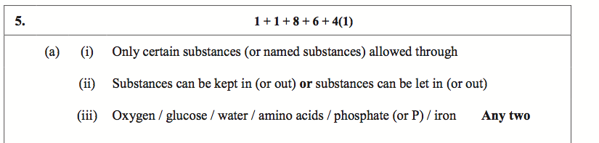
2015
5
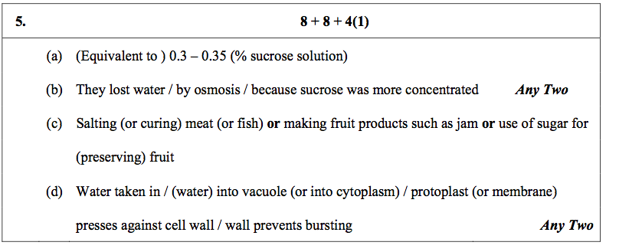

Section B

2012 HL Q7
7. | (a) | (i) | Observations or results or other | 3
 |  | (ii) | Repeats (or copies) of experiment | 3
 | (b) | (i) | Cut (open) the aorta or cut (open) the pulmonary artery | 3
 |  | (ii) | Named chemicals or named test | 3
 |  | (iii) | Milk or starch | 3
 |  | (iv) | Does not give a positive result where digestive activity occurred or described | 3
 |  | (v) | Anaerobic jar (or described) or boiled water + oil  or one with O₂ and one without O₂ (and compare) | 3
 |  | (vi) | Visking tubing or named plant tissue | 3
 |  | (vii) | IAA | 3
 |  | (viii) | *200 | 3

2013 HL Q9
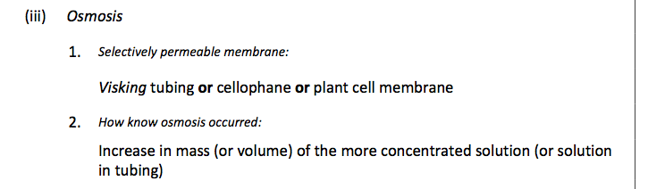
2017 9(b)
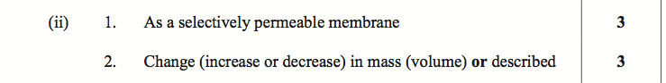

Section C

2008 HL Q14(c)
 | (c) | (i) | Diagram  Labels: dermal tissue, ground tissue, vascular tissue [accept xylem or  phloem for vascular] | 3,0  3(2)
 |  | (ii) | lower water concentration or higher solute concentration | 3
 |  | (iii) | movement of water (solvent) / along concentration gradient / through  a selectively permeable membrane | 2(3)
 |  | (iv) | membrane or plant tissue / 2 solutions indicated / different concentrations / result | 3(3)
 |  | (v) | diffusion or passive transport | 3

2010 HL Q14(c)
14. | (c) | (i) | Allowing some substances to pass through | 3
 |  | (ii) | Chloroplast / mitochondrion / nucleus / vacuole  [allow cell membrane] Any two | 2(3)
 |  | (iii) | - Movement of molecules (or substances)  from area of high concentration to area of low concentration  (or along a concentration gradient)  - Named molecule and location | 3  3  6
 |  | (iv) | Bacteria / lose water / by osmosis / inactivity or death  Any three | 3(3)

2011 HL Q14(c)
14. | (c) | (i) | Immediately inside the cell wall |  | 3
 |  | (ii) | *Eukaryotic |  | 3
 |  | (iii) | *Prokaryotic |  | 3
 |  | (iv) | Only some substances are allowed through |  | 3
 |  | (v) | No (or little) energy (or ATP) required |  | 3
 |  | (vi) | Movement of water or (osmosis) requires a membrane |  | 3
 |  | (vii) | Diagram: | container + 2 solutions separated by a membrane | (3,0)
 |  | (vii) | Labels: | membrane or plant tissue / solution 1 indicated / solution 2 indicated | 3(1)
 |  |  | Result: | Shown in diagram or stated | 3
 |  | (viii) | Contractile vacuole |  | 3

2012 HL Q15(c)
15. | (c) | (i) | homeostasis: |  | Maintenance of a constant internal environment | 3
 |  | (ii) | diffusion:  osmosis:  active transport: |  | movement of substances with (along) a concentration gradient or explained  movement of water through a selectively permeable membrane from a high water concentration to a low concentration  movement of molecules against a concentration gradient or movement of molecules using energy | 3  3  3
 |  | (iii) | 1.  2.  3. | Absorption of glucose or release of glucose or heat generation  Excretion of water or excretion of CO₂ or release of heat  Excretion of water or reabsorption of water or excretion of salts (or ions) or reabsorbtion of salts (or ions) |  | 3  3  3
 |  | (iv) | Too hot:  Sweat / dilation of blood vessels / hair flat  Too cold:  Constriction of of blood vessels / hair stands up  Insulation by (subcutaneous) fat Any three |  |  | 3(3)

2016 Q14©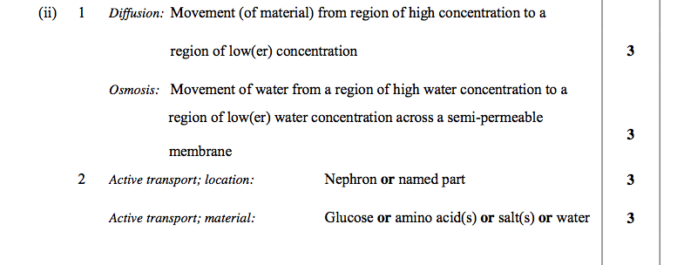

2005 OL Q7
7. | (a) | (i) | Movement or diffusion of water | 3
 |  | (ii) | Allows some molecules through /Visking tubing / cell membrane | 3
 | (b) | (i) | Diagram (minimum = 2 solutions & membrane) 6, 3, 0  Label - (title may be considered a label) | 6, 3, 0  3
 |  | (ii) | water / water plus solute / membrane or tissue / observe or result / time  (If ‘set up as above’ – then diagram must be fully labelled accordingly | 4(3)
 |  | (iii) | tissue or membrane swollen / water movement | 3

2009 OL Q8
8. |  |  |  | 5 + 1
 | (a) | (i) | (Movement of) water through (semipermeable) membrane or reference to concentration
 |  | (ii) | Any indication of water movement between cells or soil to root
 | (b) | (i) | Diagram (2 solutions / membrane)  Any three labels | 2(9) + 6(1)
 |  | (ii) | Different solutions / Observe / Time / Control /Measure /safety precaution
 |  | (iii) | e.g. heavier after
 |  | (iv) | Reference to direction of water movement

2013 OL Q8
8. | (a) |  |  | 1 + 5
 |  | (i) | Water | (1 pt)
 |  | (ii) | Diffusion/ active transport | (1 pt)
 | (b) | (i) | Diagram + 3 labels | D. 6,3,0 L.3(2)
 |  |  |  | 4(3)
 |  | (ii) | Same concentrations e.g. only water (in bag) | (1 pt)
 |  | (iii) | e.g. increase (or decrease) in mass or volume of Visking tubing | (1 pt)
 |  | (iv) | Water moved into (or out of) tubing | (1 pt)
 |  | (v) | To compare (with the experiment) | (1 pt)

2008 OL Q15(a)
15. | Answer any two of (a), (b), (c). |  |  | (30, 30, )
 | (a) |  |  | 10(3)
 |  | (i) | movement of water (essential point)  through semi-permeable membrane / from region of high osmotic potential to low osmotic potential / from high concentration of water to low concentration of water / from dilute solution to concentrated solution | One Pt  Any one of these pts
 |  | (ii) | Describe or show - apparatus/ type of membrane/ dilute solution or (distilled) water/ concentrated solution or tissue/ time period/ how change was observed / control | Four pts
 |  | (iii) | Vascular tissue / xylem
 |  | (iv) | tube-like shape/ narrow / hollow / pits in walls/strong walls / lignin
 |  | (v) | phloem  sugar / named sugar / sap / water / food | Two pts

